1. MiaoMiao
2. 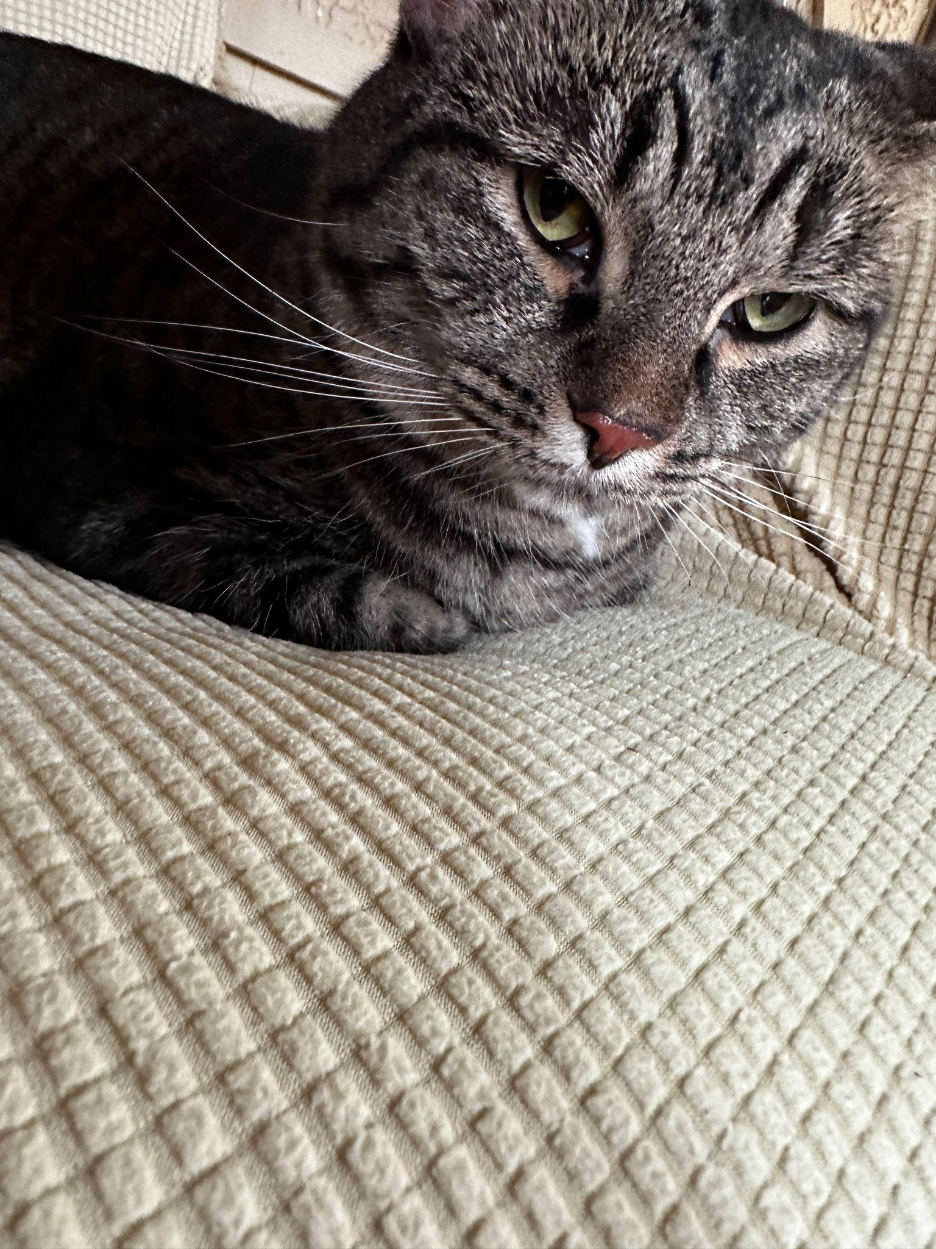
3. IMG_3088.JPG
4. A picture of MiaoMiao resting on her divine throne. A black striped with a hint of silver and brown staring at the camera with green eyes. Has paws under her body.
5. MiaoMiao is the best cat in the world, extremely social with other, and vigilant against strangers. Oftentimes you can find her running around the house looking for things to eat. If she consumed anything other than cat food, she immediately throws up.
6. She is chill and chirpy. Loves to play with anything other than professional cat toys. Prefers DIY entertainment. Pikachu,neo,Wild.When I wake up they are Chirping wildly and flying around in the house. Very social birds love when people hold them, put your hand out so they can fly to your palm.
7. *PhotoGallery*
8. V1 Michigan 339
9. PetCore
10. V1Animals Photo collage of all V1 Pets
11. V1 Pets United
12. V1/Pets
13. V1 Empire
14. V1 PetFood
15. Wild Videos V1 Pets
16. Likes
17. Anything DIY MiaoMiao
18. Bird Core : Likes chirping and running around
19. MiaoMiao Likes socializing with humans.
20. Kevin wang ,Zachary Abdirahman